**IFT 266 Introduction to Network Information Communication Technology (ICT)   
  
Lab 46**

**Router SSH Access Via Wi-Fi on IPv6**

Co-authored by Robert Kayser

**After you complete each step, put a ‘√’ or ‘x’ in the completed box**

1. Set up the following topology in packet tracer.

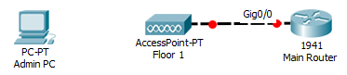



1. Install a PT-HostNM-1W-AC module on the Admin PC

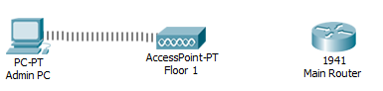



1. Configure the Main Router for IPV6

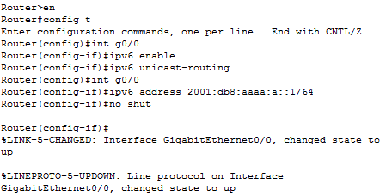



1. On Admin PC, change IPV6 Configuration to “Auto Config” to allow SLAAC to acquire a host address.

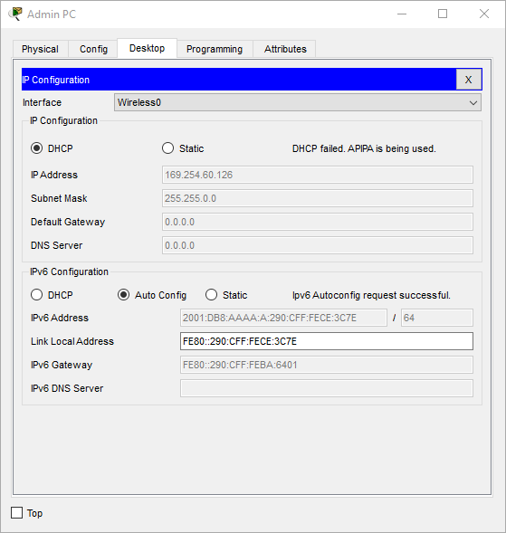



1. Now we will ll set the routers host and domain name.





1. Generate an RSA Key and enable exec mode password

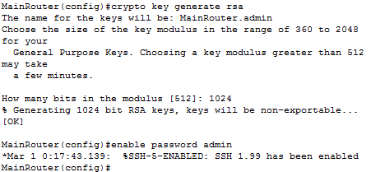



1. Configure SSH





1. Setup SSH username and password





1. Now the router is setup Check!  
     
   SSH is setup – Check!  
     
   PC is setup – Check!  
     
   We can try to connect to the router CLI remotely over Wi-Fi. Open the command prompt on the Admin PC and type the following command.

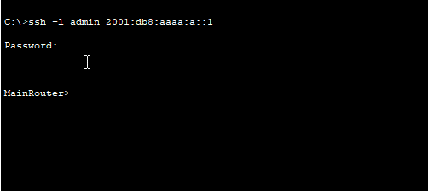



1. Do not close off the ssh connection on the PC.   
     
   Go back onto your router and run the ‘show users’ command to show your ssh connection.   
     
   Insert a screenshot of the connection below.